New York Magazine

**Business Requirement:-**

Create a single page with multi tabs to navigate to different content using React framework



Test Results:-

This is how UI home screen looks like. Upon initialization, ‘Real Estate’ tab is active. Users can then navigate to either of the other 3 tabs viz., Autos, Jobs, All Classifieds and navigate back to tabs previously visited.

Navigation Tab:- Real Estate

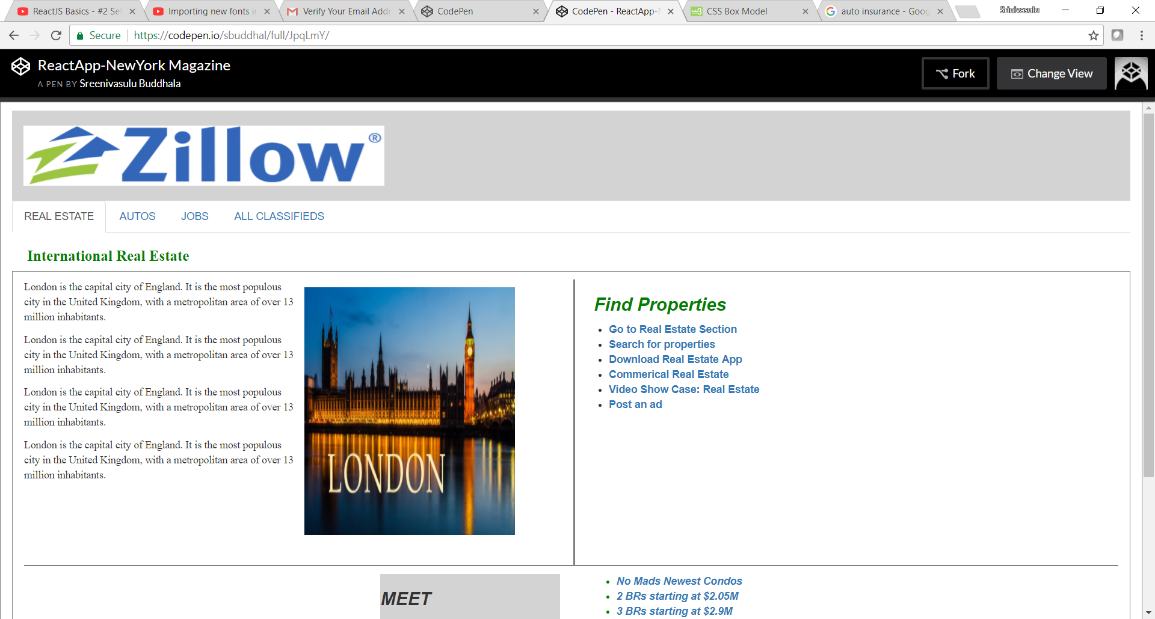

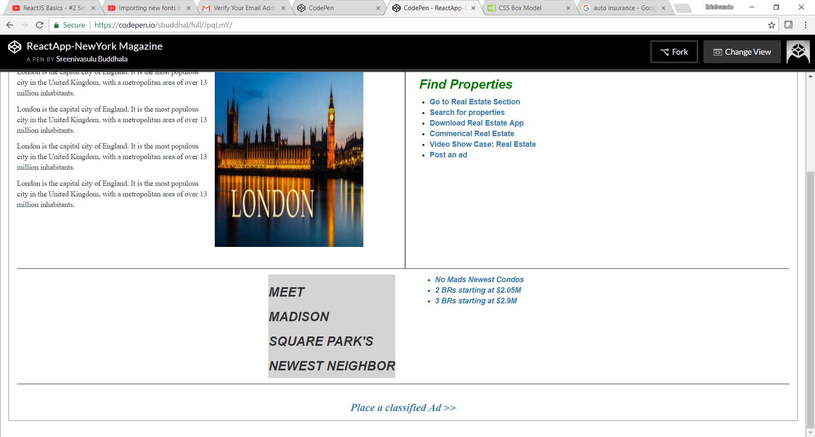

Navigation Tab: Autos

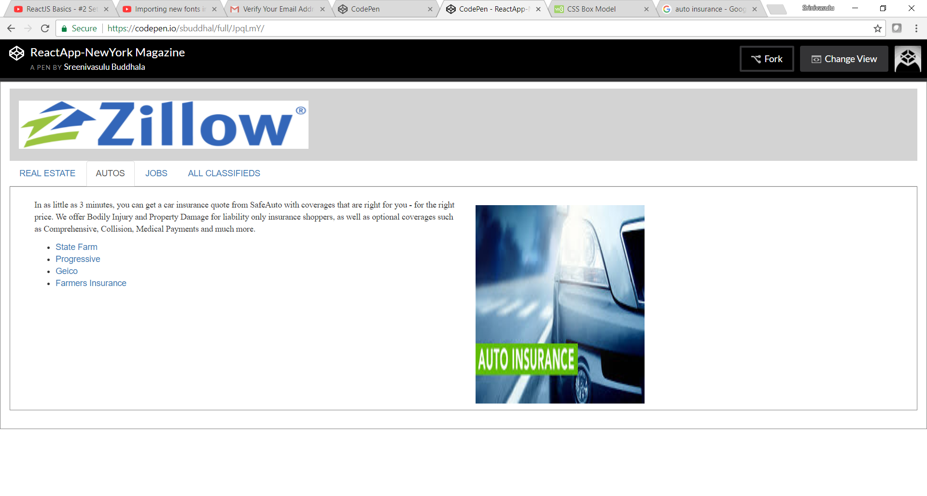

Navigation Tab: Jobs

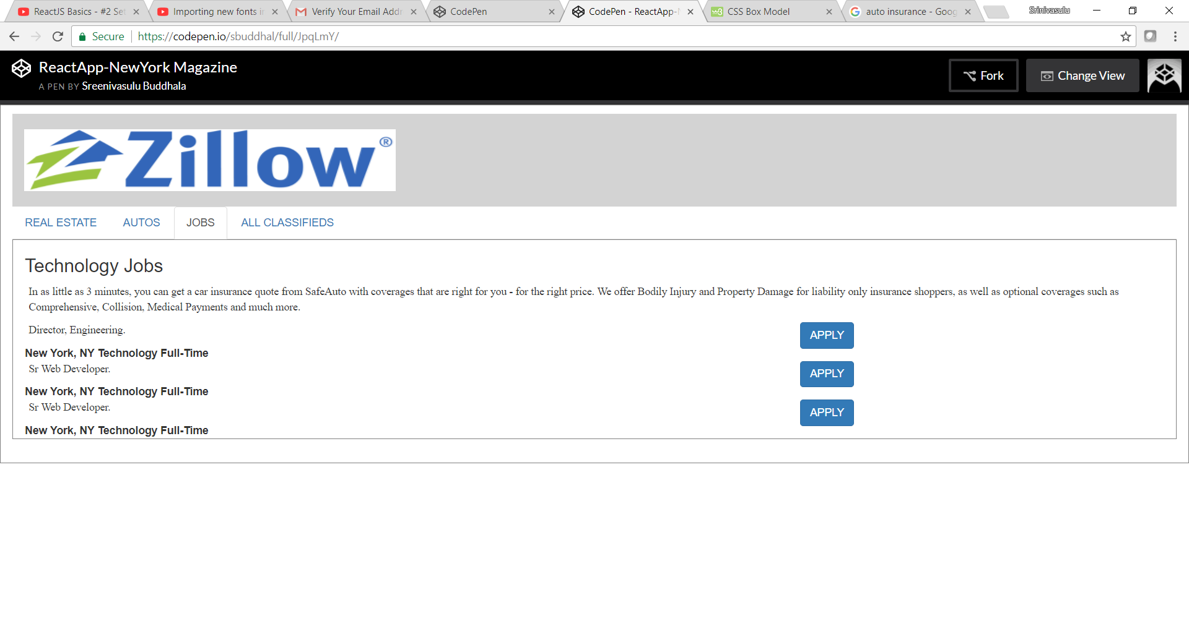

Navigation Tab: All Classifieds

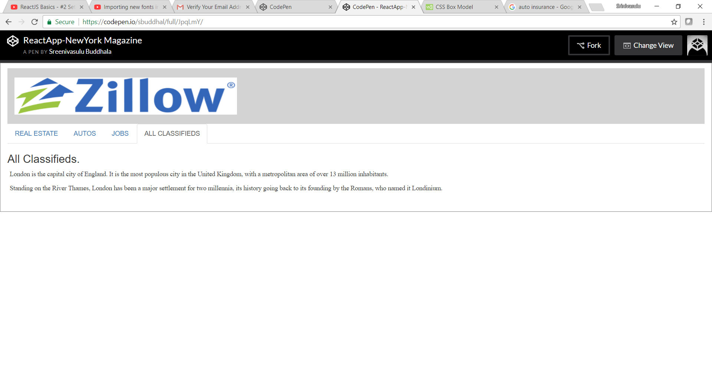

Project Tree Structure:

